

# 

COMPLAINT : 33

DATE: 13/Mar/2021

The Manager,

BANK AL-HABIB

LOL,LHR ZONE

Subject: Quotation of Repair and Maintenance. FOR APPROVAL

Number of AC: 1

|  |  |  |  |  |
| --- | --- | --- | --- | --- |
| Sr. | Job Description | Qty | Rate | Amount |
|  | Gas Charging ( upto to 2 Ton) Inverter AC Unit Unit | 2 | 4670.0 | 9340.0 |
|  | Monthly general Servicing (upto to 2 Ton) | 2 | 300.0 | 600.0 |
|  | Cable | 2rft | 44.4 | 88.8 |
|  | Cable1 | 2rft | 0.0 | 0.0 |
|  | Cable2 | 2rft | 44.0 | 88.0 |
|  | Total |  |  | 10116.8 |
|  | Tax 16% |  |  | 1618.6879999999999 |
|  | Conveynce Charges | 2 | 900 | 1800 |
|  | Total |  |  | 13535.488 |

**Yours truly,**

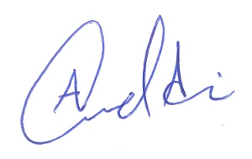 **ECO ENTERPRISES**